Odoo 15 YENİ BİR DOMAİN ATAMA
İşe başlamadan önce domaini servera yönlendirmen tüm prosesi kolaylaştıracak
etc’ nin içinde bir dosya oluştur
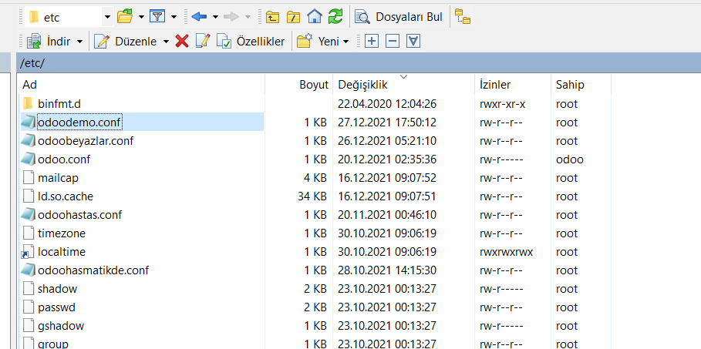
Şimdi aşağıdaki bilgileri kopyala ve bu doyanın içine yapıştır. Yapıştırmadan önce mavi renkteki port numaralarını ve dbfilteri değiştir. Db filter databasenin tam adı olmalıdır.
[options]
proxy_mode = True
; This is the password that allows database operations:
addons_path = /odoo/odoo15/odoo/odoo/addons,/odoo/odoo15/odoo/addons,/odoo/odoo15/odoo-custom-addons
admin_passwd = MyStr0ngAdminP@ssw0rd
db_host = False
db_port = False
db_user = odoo
db_password = False
xmlrpc_port = 8069
longpolling_port = 8072
workers = 2
;dbfilter = panel
;proxy_mode = true
logfile = /var/log/odoo/odoo.log
;logrotate = True

2. Şimdi
sudo nano /etc/systemd/system/odoodemo.service
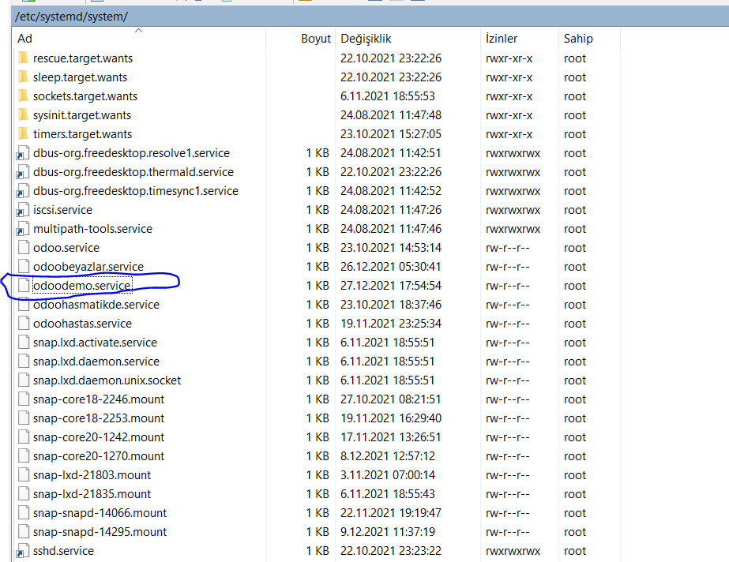
İçine aşağıdaki bilgiyi koy demo yazan yerlere kendin db adını yazabilirsin yada bir şey uydur.
[Unit]
Description=Odoo15-plusone
Requires=postgresql.service
After=network.target postgresql.service
[Service]
Type=simple
SyslogIdentifier=odoo15-plusone
PermissionsStartOnly=true
User=odoo
Group=odoo
ExecStart=/odoo/odoo-venv/bin/python3 /odoo/odoo/odoo-bin -c /etc/odoo15-plusone.conf
StandardOutput=journal+console
[Install]
WantedBy=multi-user.target

Şimdş aşağıdaki komutla servisi başlat
sudo systemctl enable --now odoodemo
şimdi burada yeni bir klasör oluştur sarı yere domain adını yaz
sudo nano /etc/nginx/sites-available/www.autoronics.com
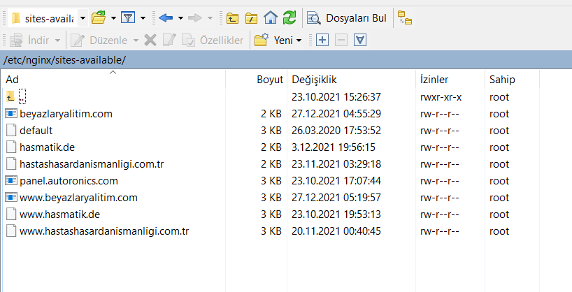
Açtığın dosyanın içine aşağıdaki bölümü koy
server {
listen 80;
server_name www.autoronics.com;
include snippets/letsencrypt.conf;
}

aşağıdaki komutla sites-available dakini anable içerisine kısa yol oluştur. Sarı yeri değiştir
sudo ln -s /etc/nginx/sites-available/www.autoronics.com /etc/nginx/sites-enabled/
sisteme test yap
nginx –t
successful yazarsa okeydir şimdi aşağıdakini yaz
sudo systemctl restart nginx
şimdi aşağıdakini yap mavi yerleri değiştir maile info@autoronics.com yaz
Kurulum Gerekirse:
apt install python3-certbot-nginx

sudo certbot --nginx --agree-tos --email info@autoronics.com --redirect --hsts -d www.domain.com

sites available için git
sudo nano /etc/nginx/sites-available/www.autoronics.com

Sites availeble içine tekrar git ve oluşturduğun dosyanın içini full sil ve bunu yaz portları değiştir domaini değiştir. odooserver ve odoochat yazan yerleri bağımsız bir funksiyon adı yap

WWW Varsa

upstream odoorush{
server 127.0.0.1:6099;
}

upstream odoorushchat{
server 127.0.0.1:6098;
}

#HTTP -> HTTPS
server {
listen [::]:80;
listen 80;
server_name www.rushbeautysalon.com rushbeautysalon.com;
return 301 https://$host$request_uri;
}

server {
listen 443 ssl http2;
server_name www.rushbeautysalon.com;

proxy_read_timeout 720s;
proxy_connect_timeout 720s;
proxy_send_timeout 720s;

# Proxy Headers
proxy_set_header X-Forwarded-Host $host;
proxy_set_header X-Forwarded-For $proxy_add_x_forwarded_for;
add_header Content-Security-Policy upgrade-insecure-requests;

#SSL CERTICATION
ssl_certificate /etc/letsencrypt/live/www.rushbeautysalon.com/fullchain.pem; # managed by Certbot
ssl_certificate_key /etc/letsencrypt/live/www.rushbeautysalon.com/privkey.pem; # managed by Certbot
ssl_trusted_certificate /etc/letsencrypt/live/www.rushbeautysalon.com/chain.pem;
include snippets/ssl.conf;
include snippets/letsencrypt.conf;

# log files
access_log /var/log/nginx/odoo.access.log;
error_log /var/log/nginx/odoo.error.log;

# Specifies the maximum accepted body size of a client request,
# as indicated by the request header Content-Length.
client_max_body_size 200m;

# increase proxy buffer to handle some odoo web requests
proxy_buffers 16 64k;
proxy_buffer_size 128k;

# Handle long poll requests
location /longpolling {
proxy_pass http://odoorushchat;
}

# Handle / requests
location / {
proxy_redirect off;
proxy_pass http://odoorush;
}

# Cache static files
location ~* /web/static/ {
proxy_cache_valid 200 90m;
proxy_buffering off;
expires 864000;
proxy_pass http://odoorush;
}
# Gzip
gzip_types text/css text/less text/plain text/xml application/xml application/json application/javascript;
gzip on;

}

server {
listen 443 ssl http2;
server_name rushbeautysalon.com;

proxy_read_timeout 720s;
proxy_connect_timeout 720s;
proxy_send_timeout 720s;

# Proxy Headers
proxy_set_header X-Forwarded-Host $host;
proxy_set_header X-Forwarded-For $proxy_add_x_forwarded_for;
add_header Content-Security-Policy upgrade-insecure-requests;

# SSL parameters
ssl_certificate /etc/letsencrypt/live/rushbeautysalon.com/fullchain.pem;
ssl_certificate_key /etc/letsencrypt/live/rushbeautysalon.com/privkey.pem;
ssl_trusted_certificate /etc/letsencrypt/live/rushbeautysalon.com/chain.pem;
include snippets/ssl.conf;
include snippets/letsencrypt.conf;

access_log /var/log/nginx/odoo.access.log;
error_log /var/log/nginx/odoo.error.log;

# Specifies the maximum accepted body size of a client request,
# as indicated by the request header Content-Length.
client_max_body_size 200m;

# increase proxy buffer to handle some odoo web requests
proxy_buffers 16 64k;
proxy_buffer_size 128k;

# Handle long poll requests
location /longpolling {
proxy_pass http://odoorushchat;
}

# Handle / requests
location / {
proxy_redirect off;
proxy_pass http://odoorush;
}

# Cache static files
location ~* /web/static/ {
proxy_cache_valid 200 90m;
proxy_buffering off;
expires 864000;
proxy_pass http://odoorush;
}
# Gzip
gzip_types text/css text/less text/plain text/xml application/xml application/json application/javascript;
gzip on;

}

WWW YOKSA

upstream odooserverdemotransfer{
server 127.0.0.1:8039;
}

upstream odoochatdemotransfer{
server 127.0.0.1:8040;
}

#HTTP -> HTTPS
server {
listen [::]:80;
listen 80;
server_name havalimanitransferyazilimi.autoronics.com;
return 301 https://$host$request_uri;
}

server {
listen 443 ssl http2;
server_name havalimanitransferyazilimi.autoronics.com;

proxy_read_timeout 720s;
proxy_connect_timeout 720s;
proxy_send_timeout 720s;

# Proxy Headers
proxy_set_header X-Forwarded-Host $host;
proxy_set_header X-Forwarded-For $proxy_add_x_forwarded_for;
add_header Content-Security-Policy upgrade-insecure-requests;

#SSL CERTICATION
ssl_certificate /etc/letsencrypt/live/havalimanitransferyazilimi.autoronics.com/fullchain.pem; # managed by Certbot
ssl_certificate_key /etc/letsencrypt/live/havalimanitransferyazilimi.autoronics.com/privkey.pem; # managed by Certbot
ssl_trusted_certificate /etc/letsencrypt/live/havalimanitransferyazilimi.autoronics.com/chain.pem;
include snippets/ssl.conf;
include snippets/letsencrypt.conf;

# log files
access_log /var/log/nginx/odoo.access.log;
error_log /var/log/nginx/odoo.error.log;

# Specifies the maximum accepted body size of a client request,
# as indicated by the request header Content-Length.
client_max_body_size 200m;

# increase proxy buffer to handle some odoo web requests
proxy_buffers 16 64k;
proxy_buffer_size 128k;

# Handle long poll requests
location /longpolling {
proxy_pass http://odoochatdemotransfer;
}

# Handle / requests
location / {
proxy_redirect off;
proxy_pass http://odooserverdemotransfer;
}

# Cache static files
location ~* /web/static/ {
proxy_cache_valid 200 90m;
proxy_buffering off;
expires 864000;
proxy_pass http://odooserverdemotransfer;
}
# Gzip
gzip_types text/css text/less text/plain text/xml application/xml application/json application/javascript;
gzip on;

}

Hem WWW Var Hemde de Yoksa

upstream odooserverantrivaviptransfer{
server 127.0.0.1:8085;
}

upstream odoochatantrivaviptransfer{
server 127.0.0.1:8086;
}

#HTTP -> HTTPS
server {
listen [::]:80;
listen 80;
server_name antrivaviptransfer.com www.antrivaviptransfer.com;
return 301 https://antrivaviptransfer.com$request_uri;
}

server {
listen 443 ssl http2;
server_name antrivaviptransfer.com www.antrivaviptransfer.com;

proxy_read_timeout 720s;
proxy_connect_timeout 720s;
proxy_send_timeout 720s;

# Proxy Headers
proxy_set_header X-Forwarded-Host $host;
proxy_set_header X-Forwarded-For $proxy_add_x_forwarded_for;
add_header Content-Security-Policy upgrade-insecure-requests;

#SSL CERTICATION
ssl_certificate /etc/letsencrypt/live/antrivaviptransfer.com/fullchain.pem; # managed by Certbot
ssl_certificate_key /etc/letsencrypt/live/antrivaviptransfer.com/privkey.pem; # managed by Certbot
ssl_trusted_certificate /etc/letsencrypt/live/antrivaviptransfer.com/chain.pem;
include snippets/ssl.conf;
include snippets/letsencrypt.conf;

# log files
access_log /var/log/nginx/odoo.access.log;
error_log /var/log/nginx/odoo.error.log;

# Specifies the maximum accepted body size of a client request,
# as indicated by the request header Content-Length.
client_max_body_size 200m;

# increase proxy buffer to handle some odoo web requests
proxy_buffers 16 64k;
proxy_buffer_size 128k;

# Handle long poll requests
location /longpolling {
proxy_pass http://odoochatantrivaviptransfer;
}

# Handle / requests
location / {
proxy_redirect off;
proxy_pass http://odooserverantrivaviptransfer;
}

# Cache static files
location ~* /web/static/ {
proxy_cache_valid 200 90m;
proxy_buffering off;
expires 864000;
proxy_pass http://odooserverantrivaviptransfer;
}
# Gzip
gzip_types text/css text/less text/plain text/xml application/xml application/json application/javascript;
gzip on;

}

Şimdi odoo servisini yeniden bŞLt
sudo systemctl restart odoodemo

nginx –t

diyerek succesfull olduğunu mutlaka gör
15-20 sn bekle
sudo systemctl restart nginx
İŞ BİTTİ. ALT TARAF İHTİYAÇ DURUMUNDA YAPILACAK.

SSl otomatik yenileme
certbot --force-renewal -d www.nixcraft.com,nixcraft.com
nginx –t

sudo systemctl restart nginx

İşin İçinden Çıkamazsan
Özellikle 502 gateway hatası için servisin çalışma durumunu kontrol et
sudo systemctl status odoo15-demotrans
hata varsa sebebi yazacaktır.
Bazen şöyle bir yeniden yükleme gerekebiliyor
systemctl daemon-reload
yukardaki komut servisteri tekrardan başlatıyor. Özellikle serviste yeniden bir değişiklik yaptıysan bu işlemi yap

SSL Otomatik Yenileme
certbot --force-renewal -d www.nixcraft.com,nixcraft.com
devamında 2 yi tuşla

https://medium.com/@othmane.ghandi/running-odoo-in-https-using-nginx-certbot-90ef2f3e5ccb

